**Peaky Blinders Season 6: Release Date and other details!** 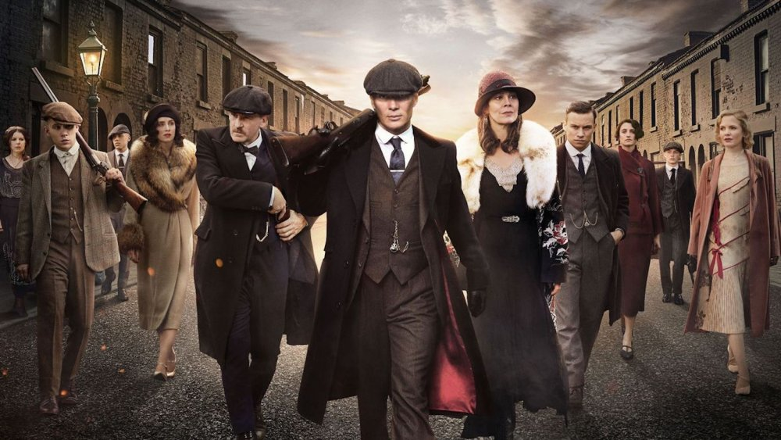

**Peaky Blinders**, a British phase crime drama television series produced by Katie Swinden and written by Steven Knight, Toby Finlay, and Stephen Russell*. Peaky Blinders season* 1 was directed by Otto Bathurst and Tom Harper, *season* 2 by Colm McCarthy, season 3 by Tim Mielants, season 4 by David Caffrey, season 5 by Anthony Byrne and **season 6** is also likely to be directed by Anthony this's because during, season 5 release in August 2019, Anthony suggested that the next season will be on the viewers' screen by early 2021. Its fans are eagerly waiting for the *release* of *season 6*. So, let's catch up on what's is here we have for you in this article.

**Peaky Blinders Season 6: Release Date**

As per the sources, there's no official announcement about the *release date* of *season 6* of *Peaky Blinders*.

During season 5 *release* in August 2019, it was suggested by the director of the series that the next series will be released by 2021 because as per the scheduled plan the series shoot and production were likely to begin in March 2020, but because of the COVID-19 pandemic, the shoot has been postponed for an indefinite period.

From that time onwards, the shoot wasn't able to begin in awake of the pandemic but it's likely to begin in the next few months. So, we can expect its release by ending of 2021 or the start of 2022 on *Netflix*.

**Peaky Blinders Season 6: Probable Cast**

We're anticipating that the lead actors will be returning in their roles as per the previous seasons. And there may be an introduction of a few more characters but nothing has been revealed yet. Actors who are likely to repeat their characters are:

Cillian Murphy as Thomas "**Tommy**" **Shelby**, the chief of the Peaky Blinders.

Helen McCrory being Elizabeth "Polly" Gray, Thomas's aunt and treasurer of the Peaky Blinders.

Finn Cole being Michael Gray, Biological son of Helen McCrory

Paul Anderson being Arthur Shelby, the eldest Shelby sibling

Natasha O'Keeffe being Lizzie Shelby, Tommy's secretary and his second wife, and the mother of his daughter Ruby.

Sophie Rundle being Ada Thorne, Shelby's brother's sister.

Tom Hardy being Alfred "Alfie" Solomons, the chief of the Jewish group in Camden Town.

Sam Clafin being Oswald Mosley, a politician

Anna Taylor-Joy being Gina Gray, Michael Gray's American wife

And few more characters may appear in the new season but there's no official news on the same. 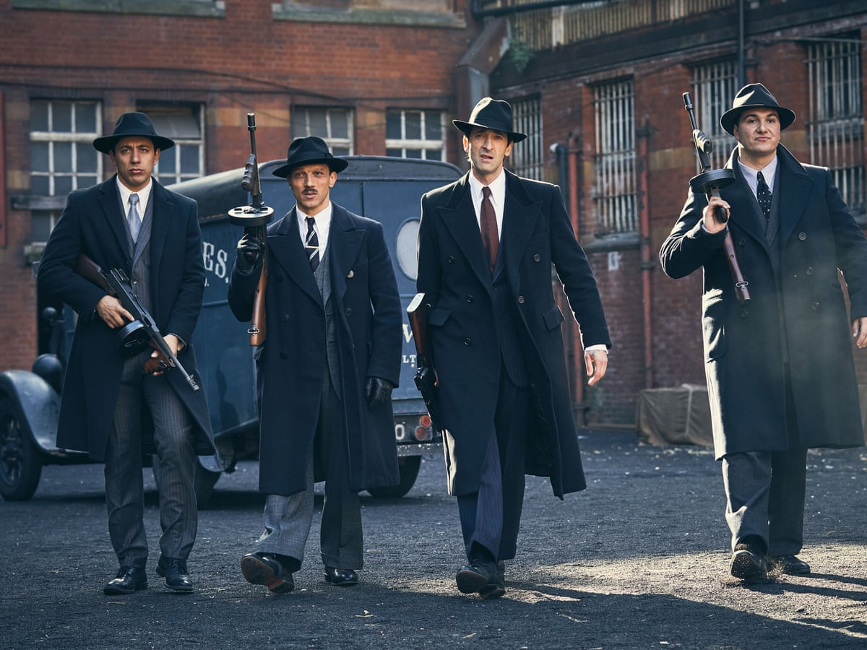

**Peaky Blinders Season 6: Expected Plot**

As one can remember from the ending of season 5 that *Tommy Shelby* was holding a gun to his head, so **season 6** is likely to get started from that scene. Then as per the director's statement, *season 6* will deal with unveiling the person who betrayed Tommy and scraped his plan to murder Mosley. Additionally, as per the writer of the series, viewers will be experiencing a time jump in *season 6* as well. Oswald Mosley will be returning in the show because he escaped from Tommy's plan to kill him. Gina Gray's family is also likely to be introduced to the viewers. So, there's a lot of things one can expect from the storyline of *season 6*.

**Peaky Blinders season 6: Trailer**

Since the production for *season 6* of *Peaky Blinder* has not yet begun, so there's no *release* of the **trailer** of the same by **Netflix**. We can expect the *trailer* to be released by the starting of 2022 or the ending of 2021, depending upon when the shoot begins. Till that time, you can enjoy the *trailer* of season 5 of *Peaky Blinder*😊

https://www.youtube.com/watch?v=Ruyl8_PT_y8